**Project**

Churn Prediction in Telecom Industry Using R

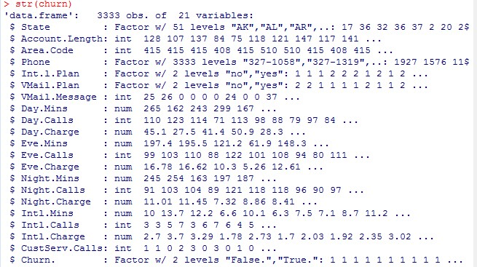Description of data attributes

Summary

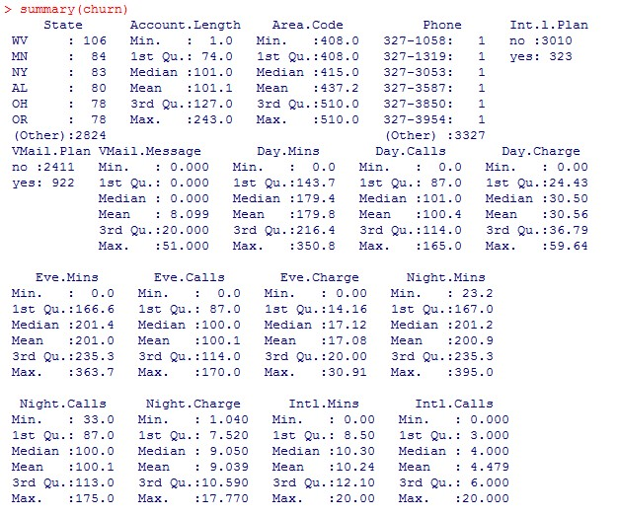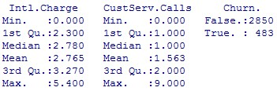

Decision Tree

Decision Tree

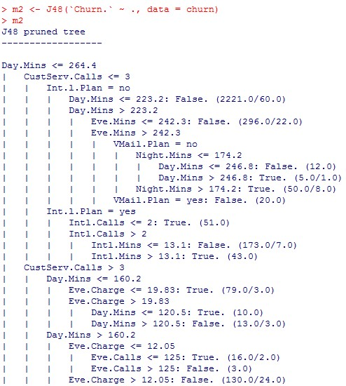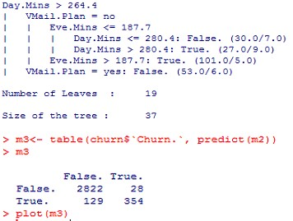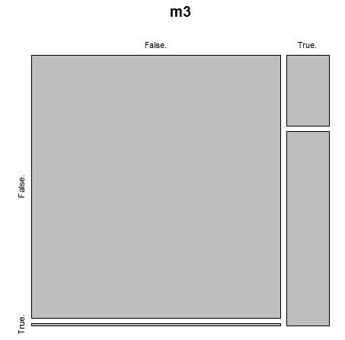

-

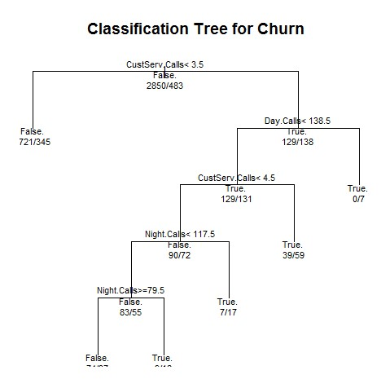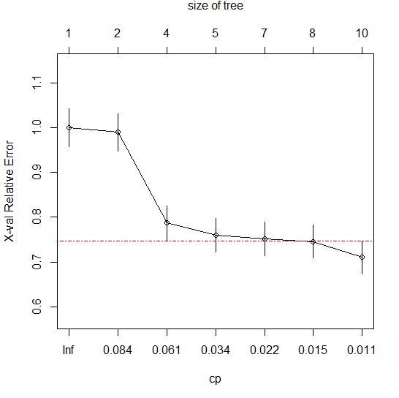

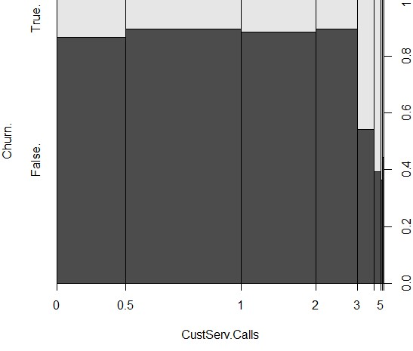

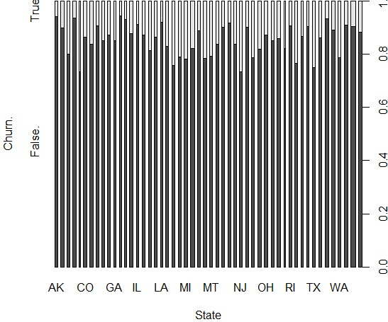

Line Chart:

|  |
| --- |
| # convert factor to numeric for convenience churn$Churn. <- as.numeric(churn$Churn.) ntrees <- max(churn$Churn.)  # get the range for the x and y axis xrange <- range(churn$Day.Calls) yrange <- range(churn$CustServ.Calls)  # set up the plot  plot(xrange, yrange, type="n", xlab="Day.Calls (num)", ylab="CustServ.Calls(num)" ) colors <- rainbow(ntrees) linetype <- c(1:ntrees)  plotchar <- seq(15,15+ntrees,1)  # add lines for (i in 1:ntrees) {  tree <- subset(churn, Churn.==i)  lines(tree$Day.Calls, tree$CustServ.Calls, type="b", lwd=1.5, lty=linetype[i], col=colors[i], pch=plotchar[i]) }  # add a title and subtitle title("Churn", "line plot")  # add a legend  legend(xrange[1], yrange[2], 1:ntrees, cex=0.8,  col=colors,pch=plotchar, lty=linetype, title="Tree") |

Churn and International Plan

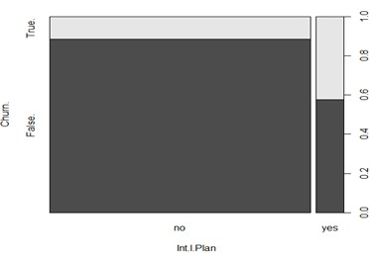

Churn:





